Title: Matter-Mover

Character: A mover

Type: Block puzzle game

Target Audience: Preschool age and up

Setting: Modern day

View: Top Down

Number of Players: 1

Intended length of Play: 3-5 (depends on number of levels)

Details of what players are doing: pick up items and load them into the truck to obtain points and level up in the company.

Controls:

* WASD to move
* spacebar to grab
* left right arrow keys to rotate cargo

Theme: You are new at a moving company and are loading a truck with random shaped items. Move up the ranks at the moving company by doing jobs and packing the truck efficiently.

Art style: flat colors, simple, pixel art

Features

* Sounds
  + Background song
  + picking up/ dropping items
* Important
  + Player movement
  + Being able to pick up/move items
  + Checking how full area is
* Optional
  + Loading size option in latter levels
  + Player receives a score depending on how well they fill the platform
  + A time limit to push the player to make quick decisions
  + Cargo weight so that heavier objects are moved slowly
  + Ability to drop items

Concept Art:

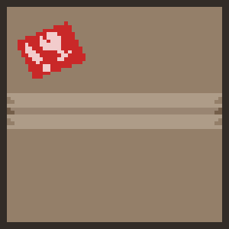



Prototype:

